Bahria University,

Karachi Campus



COURSE: CSC-113 COMPUTER PROGRAMMING

TERM: FALL 2019, CLASS: BSE- 1 (B)

Submitted By:

M MUAZ SHAHZAD 02-131202-081

(Name) (Reg. No.)

Submitted To:

Engr. Adnan ur rehman/ Engr. Ramsha Mashood

Signed Remarks: Score:

INDEX

|  |  |  |  |  |
| --- | --- | --- | --- | --- |
| SNO | DATE | LAB NO | LAB OBJECTIVE | SIGN |
| 01 | 20-Oct-2020 | 04 | FORMATTED OUTPUT |  |
|  |  |  |  |  |
|  |  |  |  |  |
|  |  |  |  |  |
|  |  |  |  |  |
|  |  |  |  |  |
|  |  |  |  |  |
|  |  |  |  |  |
|  |  |  |  |  |
|  |  |  |  |  |
|  |  |  |  |  |
|  |  |  |  |  |
|  |  |  |  |  |
|  |  |  |  |  |
| SNO | DATE | LAB NO | LAB OBJECTIVE | SIGN |
|  |  |  |  |  |
|  |  |  |  |  |
|  |  |  |  |  |
|  |  |  |  |  |
|  |  |  |  |  |
|  |  |  |  |  |
|  |  |  |  |  |
|  |  |  |  |  |
|  |  |  |  |  |
|  |  |  |  |  |
|  |  |  |  |  |
|  |  |  |  |  |
|  |  |  |  |  |
|  |  |  |  |  |
|  |  |  |  |  |

Bahria University,

Karachi Campus



LAB EXPERIMENT NO.

**04**

LIST OF TASKS

|  |  |
| --- | --- |
| TASK NO | OBJECTIVE |
| 01 | Execute all examples code and attach output in your lab file |
| 02 | Create a small form which take following input from an employee of any company   1. Name 2. Father name 3. Phone No 4. Designation 5. Date Of Hiring 6. Salary   Using above information display user profile in a formatted manner. |
| 03 | Create a simple C# program in which you will display the restaurant payment bill in formatted manner |
|  |  |
|  |  |
|  |  |
|  |  |
|  |  |
|  |  |
|  |  |
|  |  |

Submitted On:

28/10/2020

(Date: DD/MM/YY)

**Task No. 1: Execute all examples code and attach output in your lab file**

**Solution:  
Example 1:**

namespace Lab_4_example_1

{

class Program

{

static void Main(string[] args)

{

Console.WriteLine("{0,5} {1,5}", 123, 456); // Right-aligned

Console.WriteLine("{0,-5} {1,-5}", 123, 456); // Left-aligned

Console.WriteLine("{0,-10:D6} {1,-10:D6}", 123, 456); // D6 means 6 decimal digits

Console.ReadLine();

}

}

}

**Output:**

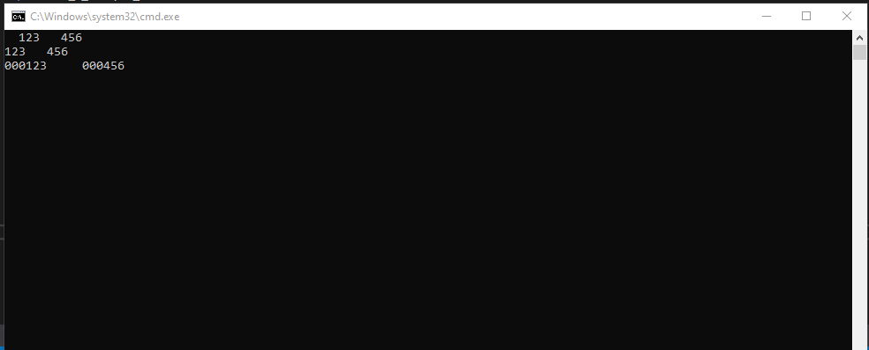

**Example 2:  
Solution:**namespace CP_lab_4_Ex_2

{

class Program

{

static void Main(string[] args)

{

int i = 2;

Console.WriteLine("{0:C}", i);

Console.WriteLine("{0:D}", i);

Console.WriteLine("{0:E}", i);

Console.WriteLine("{0:F}", i);

Console.WriteLine("{0:G}", i);

Console.WriteLine("{0:N}", i);

Console.WriteLine("{0:P}", i);

Console.WriteLine("{0:X}", i);

Console.ReadKey();

}

}

}

**Output:**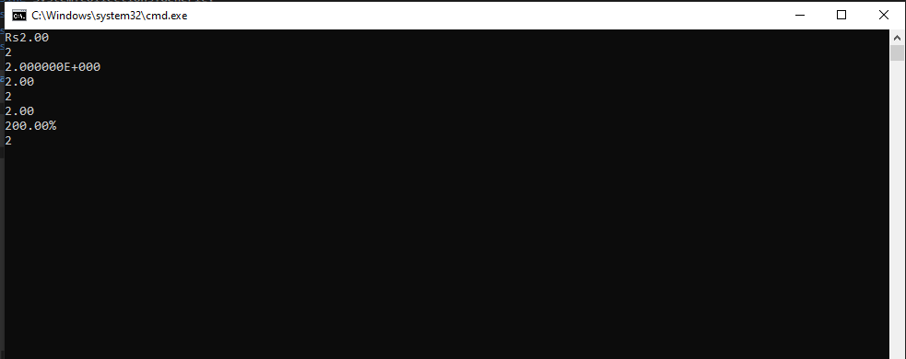

**Example 3:**

**Solution:**namespace Cp_Lab_4_Tasks_ex_3

{

class Program

{

static void Main(string[] args)

{

DateTime d = new DateTime(2018, 2, 8, 12, 7, 7, 123);

Console.WriteLine(String.Format("{0:y yy yyy yyyy}", d));

Console.WriteLine(String.Format("{0:M MM MMM MMMM}", d));

Console.WriteLine(String.Format("{0:d dd ddd dddd}", d));

}

}

}

**Output:**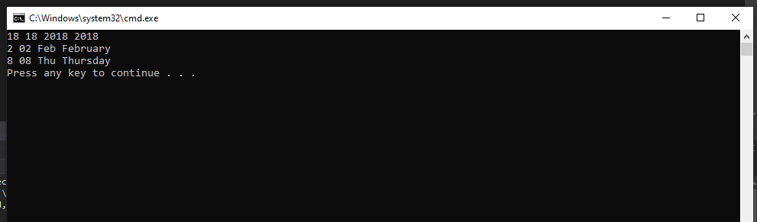

**Example 4:  
Solution:**namespace Cp_Lab_4_ex_4

{

class Program

{

static void Main(string[] args)

{

int firstNumber = 5, secondNumber = 10, result;

result = firstNumber + secondNumber;

Console.WriteLine("{0} + {1} = {2}", firstNumber, secondNumber, result);

}

}

}

**Output:**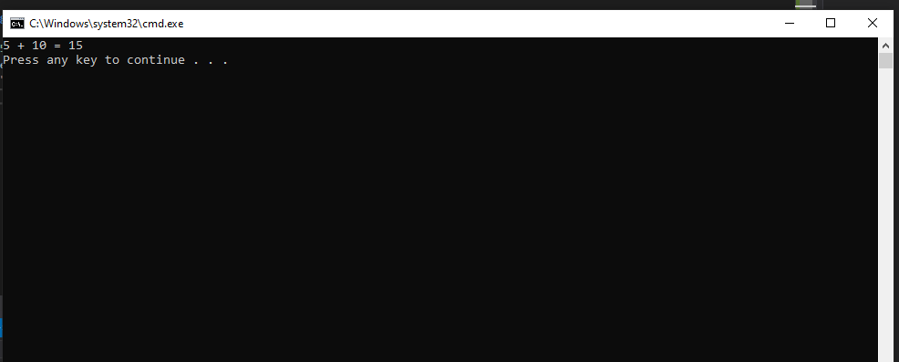

**Example 5:  
Solution:**namespace Cp_lab_4_ex_5

{

class Program

{

static void Main(string[] args)

{

Console.WriteLine("Three decimal places...");

Console.WriteLine(String.Format("{0:0.000}", 987.383));

Console.WriteLine(String.Format("{0:0.000}", 987.38));

Console.WriteLine(String.Format("{0:0.000}", 987.7899));

Console.WriteLine("Thousands Separator...");

Console.WriteLine(String.Format("{0:0,0.0}", 54567.46));

Console.WriteLine(String.Format("{0:0,0}", 54567.46));

}

}

}  
  
  
**Output:**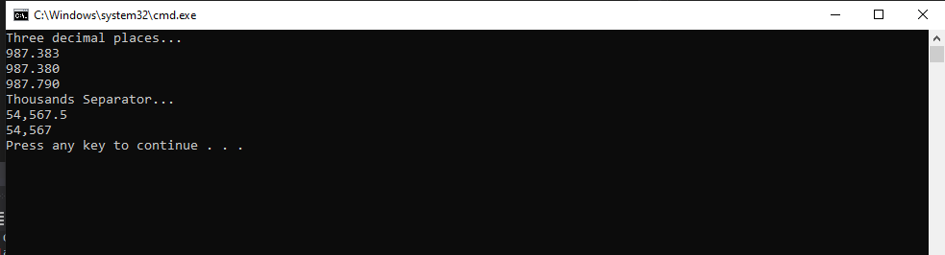

**Task No. 2: Create a small form which take following input from an employee of any company   
 Name  
 Father name   
 Phone No  
 Designation  
 Date Of Hiring  
 Salary  
Using above information display user profile in a formatted manner.  
  
  
Solution:**namespace Cp_lab_4_task_2

{

class Program

{

static void Main(string[] args)

{

string name, fatherName, designation;

Console.Write("Enter Name : ");

name = Console.ReadLine();

Console.Write("Enter Father Name: ");

fatherName = Console.ReadLine();

double phone;

Console.Write("Enter Your Phone No : ");

phone = Convert.ToInt64(Console.ReadLine());

Console.Write("Enter Designation: ");

designation = Console.ReadLine();

int year, month, day;

Console.Write("Enter Year: ");

year = int.Parse(Console.ReadLine());

Console.Write("Enter Month: ");

month = int.Parse(Console.ReadLine());

Console.Write("Enter Day: ");

day = int.Parse(Console.ReadLine());

DateTime d = new DateTime(year, month, day);

double c;

Console.Write("Salary : ");

c = Convert.ToDouble(Console.ReadLine());

Console.WriteLine("======================================================");

Console.WriteLine("{0,35}", "EMPLOYEE INFORMATION");

Console.WriteLine("======================================================");

Console.WriteLine("NAME : " + name);

Console.WriteLine("FATHER NAME : " + fatherName);

Console.WriteLine("DESIGNATION : " + designation);

Console.WriteLine("DATE OF HIERING : " + d.ToShortDateString());

Console.WriteLine("PHONE NUMBER : " + phone);

Console.WriteLine("{0,0}{1,1:c}", "SALARY : ", c);

}

}

}

**Output:**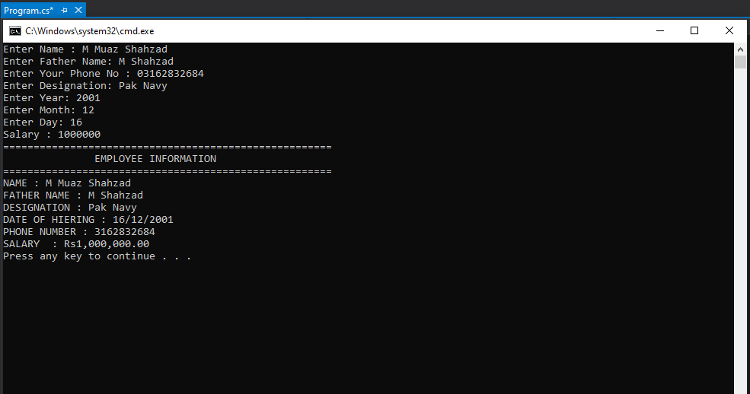

**Task No. 3:** **Create a simple C# program in which you will display the restaurant payment bill in formatted manner  
  
Solution:**namespace Restuarant_slip

{

class Program

{

static void Main(string[] args)

{

String Name = "Karachi Restaurant";

Console.WriteLine("|{0,40} |", Name);

String Address1 = "Dalmian Karachi ";

String Address2 = "Near National Stadium";

Console.WriteLine("|{0,38} |", Address1);

Console.WriteLine("|{0,43} |", Address2);

Console.WriteLine("| |");

DateTime d = new DateTime(2020, 3, 20, 10, 40, 56);

Console.WriteLine("|{0,59:d-MMM-yyy HH:mm:ss tt} |", d);

Console.WriteLine("|------------------------------------------------------------|");

String T = "Table:";

string c = "Chk:";

String G = "Guest:";

int s = 201;

int p = 1111;

int a = 2;

Console.WriteLine("|{0,10}{3,1} {1,16} #{4,1} {2,21}{5,1} |", T, c, G, s, p, a);

Console.WriteLine("|------------------------------------------------------------|");

Console.WriteLine("| |");

String F = "Burger";

String C = "Drink";

int n = 7;

int t = 4;

double k = 1400;

double l = 500;

Console.WriteLine("|{1,23} {0,6} {2,8:C} |", F, n, k);

Console.WriteLine("|{1,23} {0,3} {2,2:C} |", C, t, l);

Console.WriteLine("| |");

String Q = "SUBTOTAL";

String X = "TAX";

String D = "TOTAL DUE";

int S = (1400 + 500);

int o = 100;

int Z = (100 + 1900);

Console.WriteLine("|{0,30} {1,2:C} |", Q, S);

Console.WriteLine("|{0,30} {1,2:C} |", X, o);

Console.WriteLine("|{0,30} {1,2:C} |", D, Z);

Console.WriteLine("| |");

Console.WriteLine("|------------------------------------------------------------|");

String N = "THANK YOU FOR DINNING WITH US!";

Console.WriteLine("|{0,45} |", N);

String M = "Always be Happy";

Console.WriteLine("|{0,37} |", M);

Console.WriteLine("|------------------------------------------------------------|");

}

}

}

**Output:**